**X Linked Inheritance Google Web Links**

**Get this first: Tips and Instructions Link:**

<https://docs.google.com/document/d/1fp9CRwfKk_9AOv_HdsDGLExjGo-v8TeAdL56tH6OTAQ/template/preview>

**Then select and click the link for which version you’d like to download to your own drive below:**

­X Linked Inheritance DD Student Blank:

<https://docs.google.com/presentation/d/1Fd9u7VhNzYeh4vpbGsWhwaEAjcpH8KA5l4ayoKYdsXw/template/preview>

X Linked Inheritance DD Student FiB(Fill in Blank): <https://docs.google.com/presentation/d/1dvv3exr0cuibiuj2baYOUlAcwPy5dsZEYoLD-NKudyM/template/preview>

X Linked Inheritance DD Student wH(With Headers):

<https://docs.google.com/presentation/d/1MGt2plu5oEbTJ3CqIV7tPw5BTUjj0Kc0qymNvbwjoRQ/template/preview>

X Linked Inheritance DD Teacher Key:

<https://docs.google.com/presentation/d/1XYYhP8jlNPcHWpMIDYHLmidlsDwlbkOUYRX5VCslJiA/template/preview>

X Linked Inheritance DD Teacher Key FiB:

<https://docs.google.com/presentation/d/11D-V4LgKtTePjyBLXeTK1YOS15fKoFXwFE7rw8ZvZs0/template/preview>

Google-Compatible Resource - Terms of Use:

[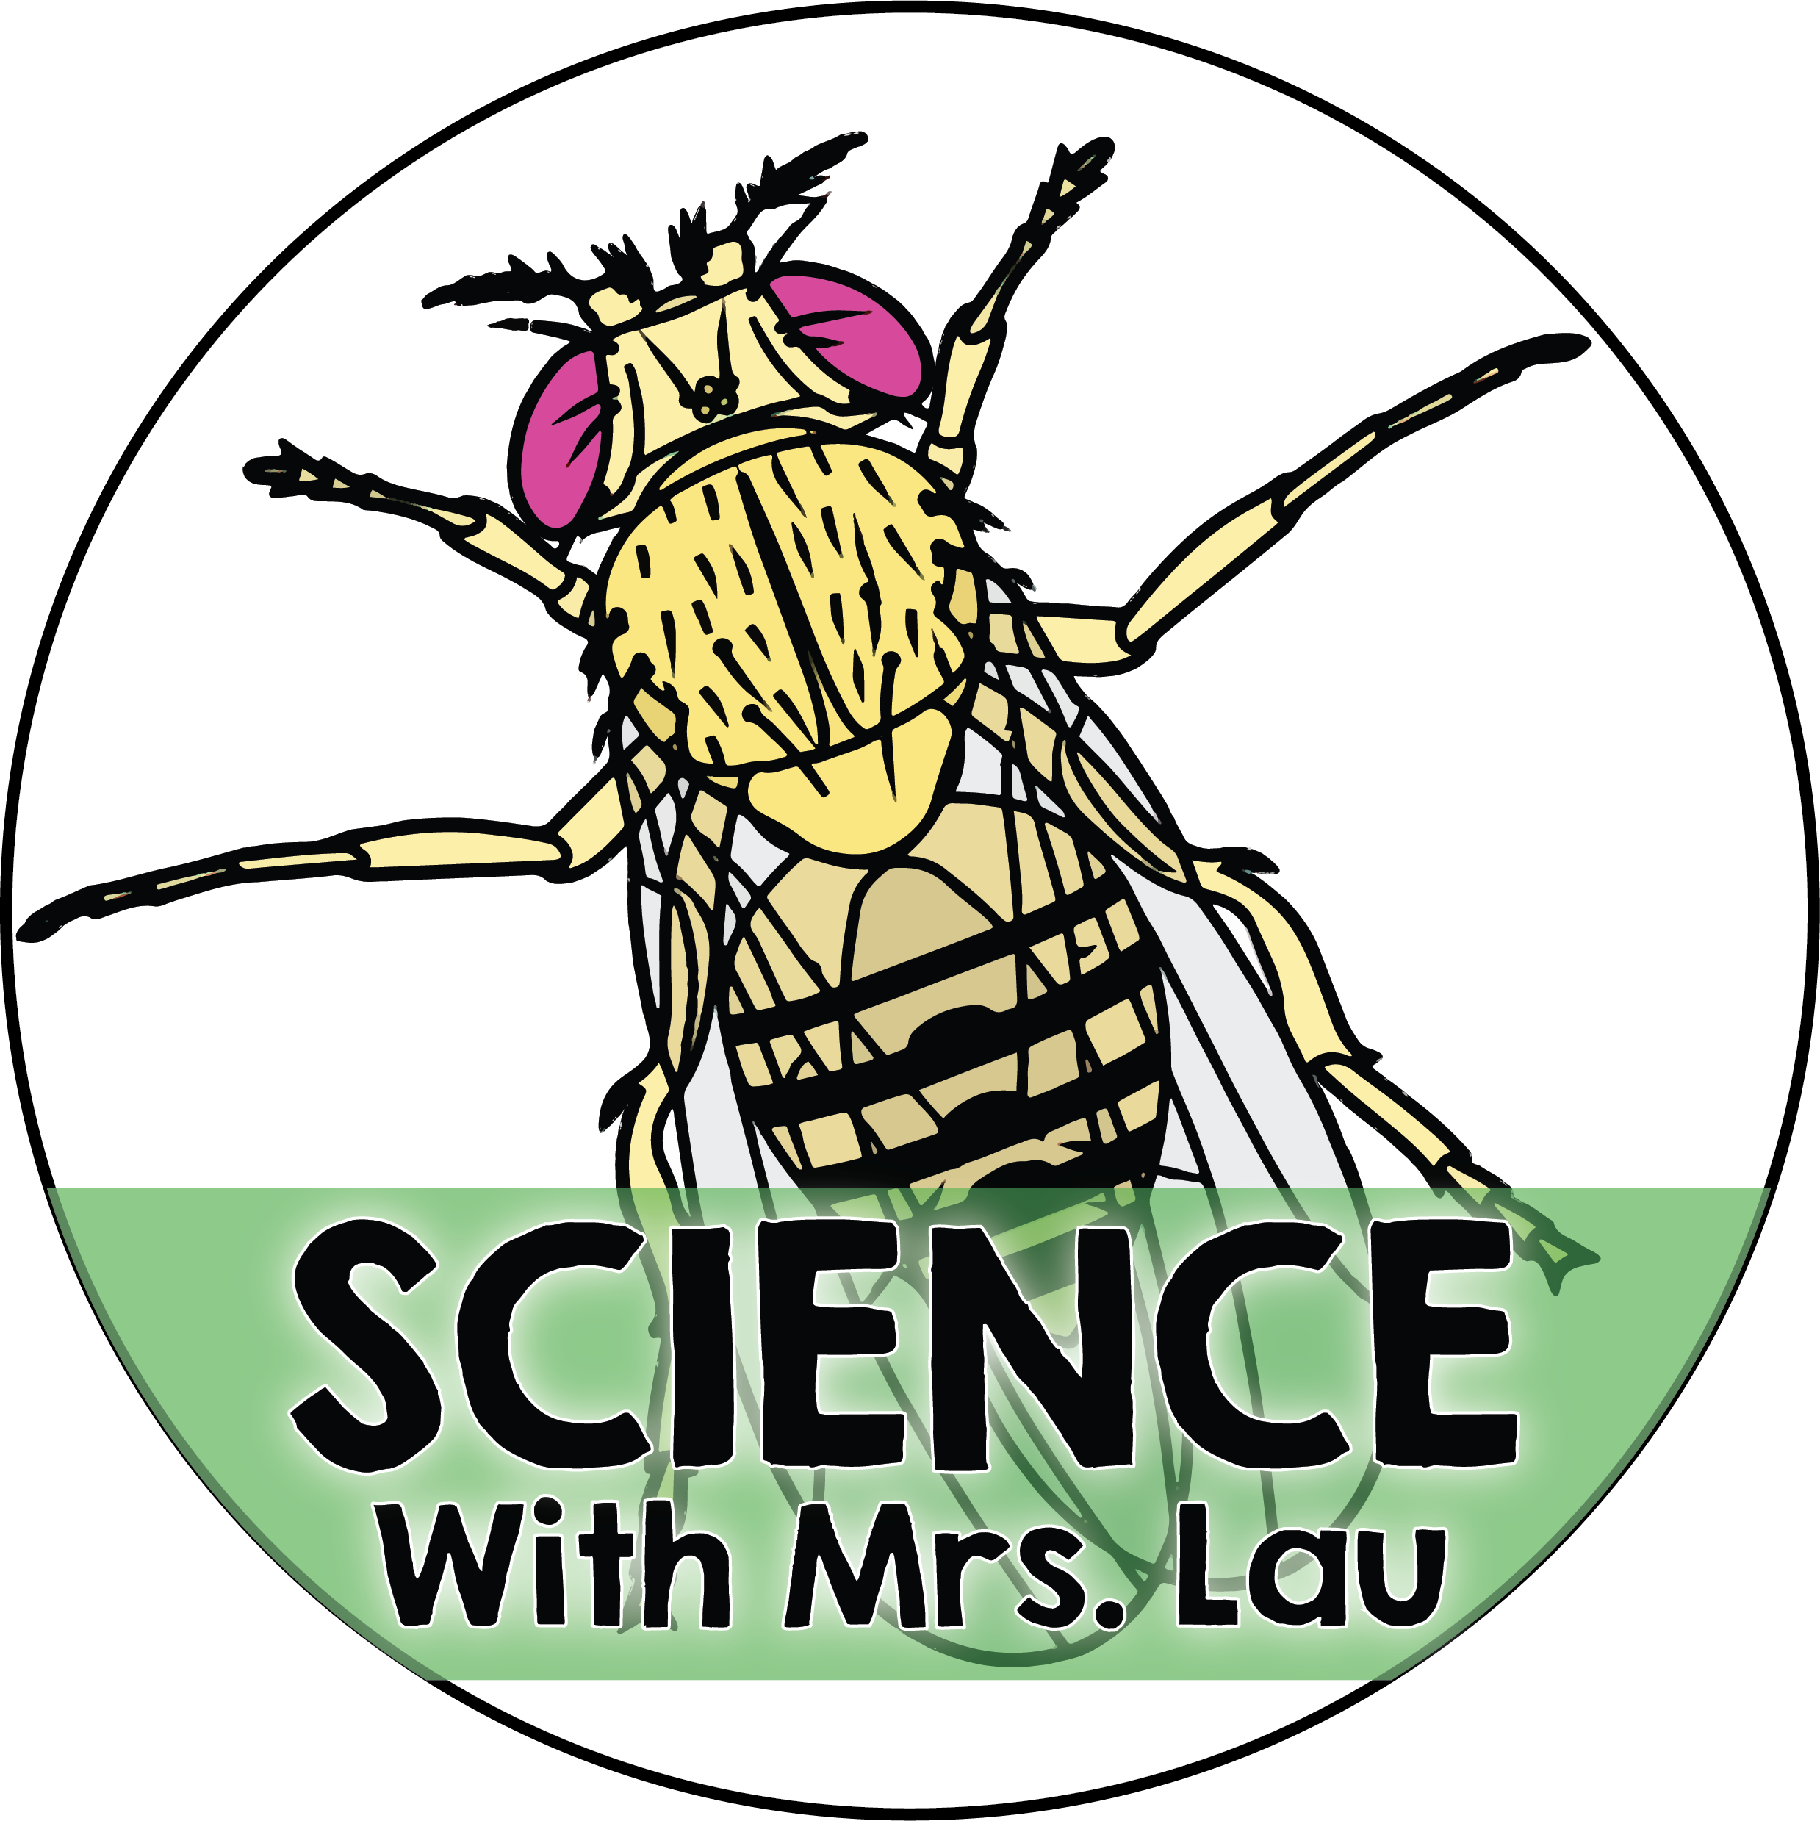](https://www.teacherspayteachers.com/Store/Science-With-Mrs-Lau)

The purchase of this Google-compatible resource from Science with Mrs. Lau includes a limited license for your classroom use. You may utilize this resource for each of your students.

This product may not be copied and distributed outside of the scope of your classroom.

This product may not be uploaded to the internet or stored in a public retrieval system outside of the scope of the project itself.

The Google templates and files included in this resource may not be used to create something new, and or, distributed in any way without written consent from the author, Bethany Lau.

[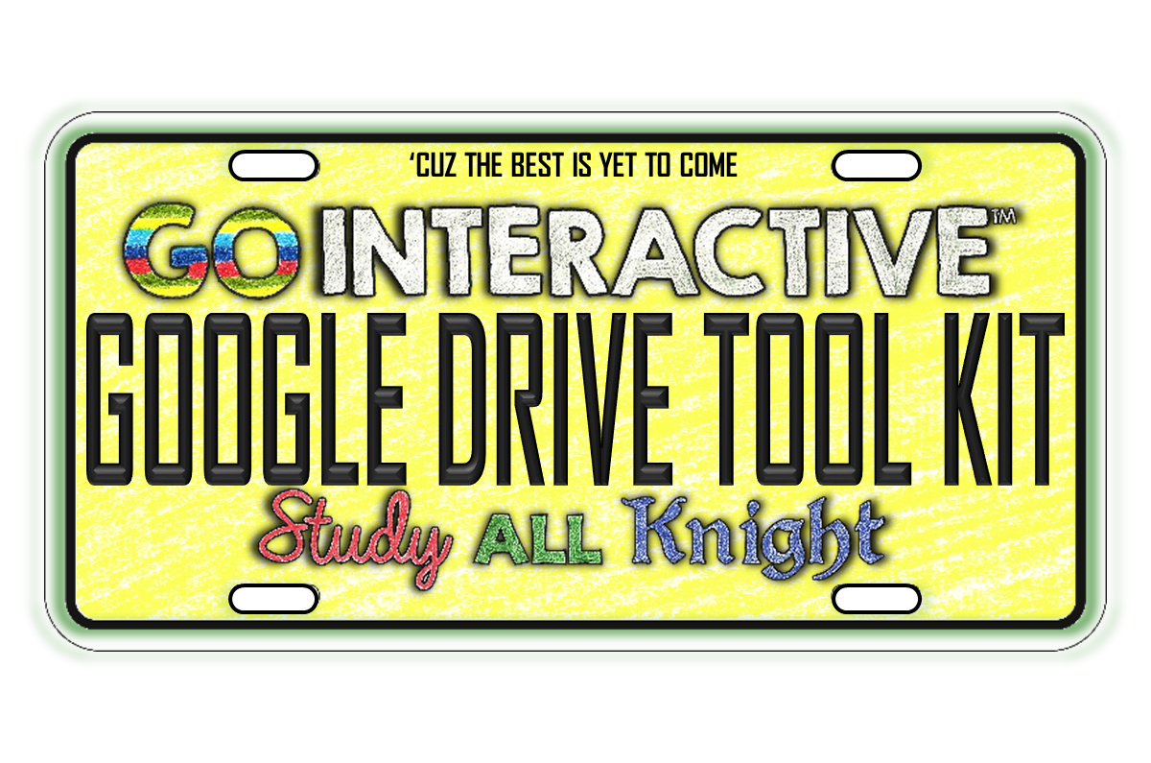](https://www.teacherspayteachers.com/Product/TOOLKIT-FOR-GOOGLE-DRIVE-PAPERLESS-CLASSROOM-AND-DIGITAL-NOTEBOOKS-2203339)If you have any questions pertaining to the limited license for this product, please contact Bethany Lau at [mrs.bethany.lau@gmail.com](mailto:mrs.bethany.lau@gmail.com)